# How to avoid a bad channel count?

When you create your own fixture, build in more than 1 mode, it can easily happen that the DMX Channel count of your fixture is wrong.

This document will show you why, and how to avoid it.

## Why the DMX Channel count can be wrong?

The DMX Channel count per mode of Realizzer 3D is based on the highest DMX Channel number you have set inside the DMX Mode Chart.

This bad DMX Channel count only happens when between the modes of your fixtures, the channel precision is changed (from 16 bits to 8 bits as example).

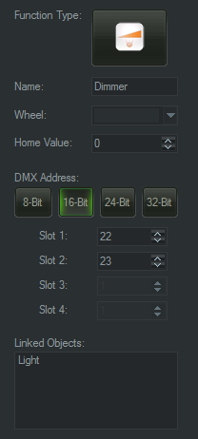 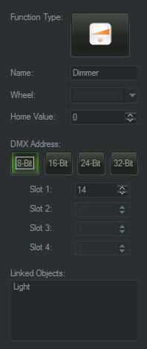

Change the channel precision from 16 bits to 8 bits

When you change the channel precision, Realizzer hide the un-needed field, but keep in mind the channel used. In the example illustrated, the channel 23 is kept in memory for the actual mode, where our new channel number is 14.

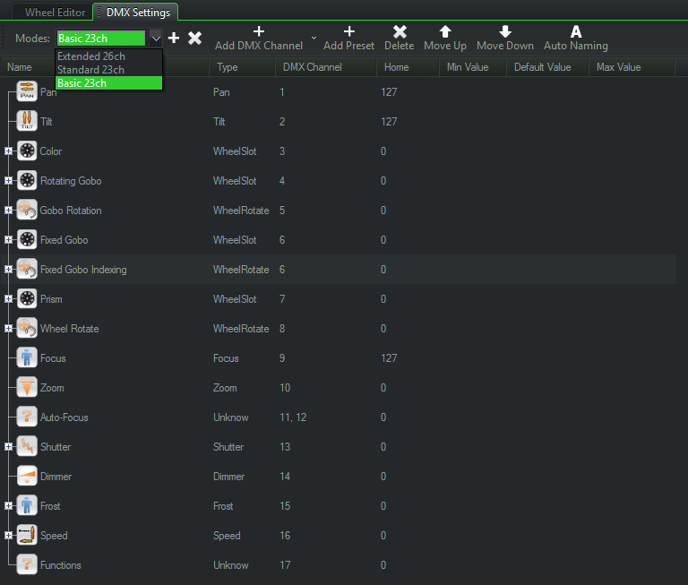  
Result of bad channel count per mode

As result, you can see that the fixture provided as example as 3 modes where the 2 modes (Standard & Basic) are displayed with 23 channels, but in reality it is a fixture with Standard 19ch and Basic 17ch.

## How to avoid and fix issue with the DMX Channel count?

That’s quite easy, you just need to think about it.

Each time you change the DMX Precision of a channel, think firstly to **set the un-needed field to** **0**. Then you can change the DMX Precision safely:

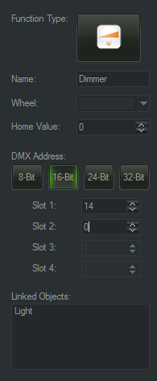 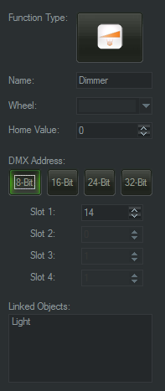  
Safe DMX Precision change